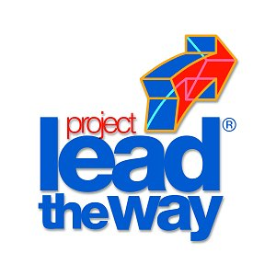
Project 2.2.2 - Technical Scavenger Hunt

Purpose
The World Wide Web, or internet as it is also called, has been referred to as the information highway. Like any other major highway, if the traveler is not familiar with the rules and signage, the trip can be almost impossible.

Searching for information on the internet can be very frustrating because of the volume of available information. This is why it is important to understand how to effectively navigate the internet to retrieve specific bits of information.

Before the Internet came along, research was done using bound printed research materials or those saved on microfiche. Sometimes interlibrary loans had to be arranged to secure the necessary text.

Equipment
- Engineer’s notebook
- Computer with word processing and internet access
- Printer
- Bound research materials

Procedure
In this project, you are going to search the World Wide Web or internet to retrieve information on ten different topics. Your media center may have bound research materials that can also be used.

Using the available resources in your media center, find the answers to the following questions. Print out your answers and give them to your teacher.

- What is the molecular structure of nylon?
- What is the composition of INCONEL 718?
- Who designed the Brooklyn Bridge?
- How does a turbofan differ from a turbojet?
- Who holds US Patent 4,608,967, and what is it for?
- Where does asphalt come from?
- How many engines did the second stage of the Saturn-V have?
- What is the elevation change across Niagara Falls?
- How much does an aircraft carrier weigh?
- What is the Optical Time Domain Reflectometer (OTDR) used for?

Conclusion
- What information can you gain by being able to navigate the US Patent Office website efficiently?

- What suggestion would you give to your media specialist to make your research easier?

